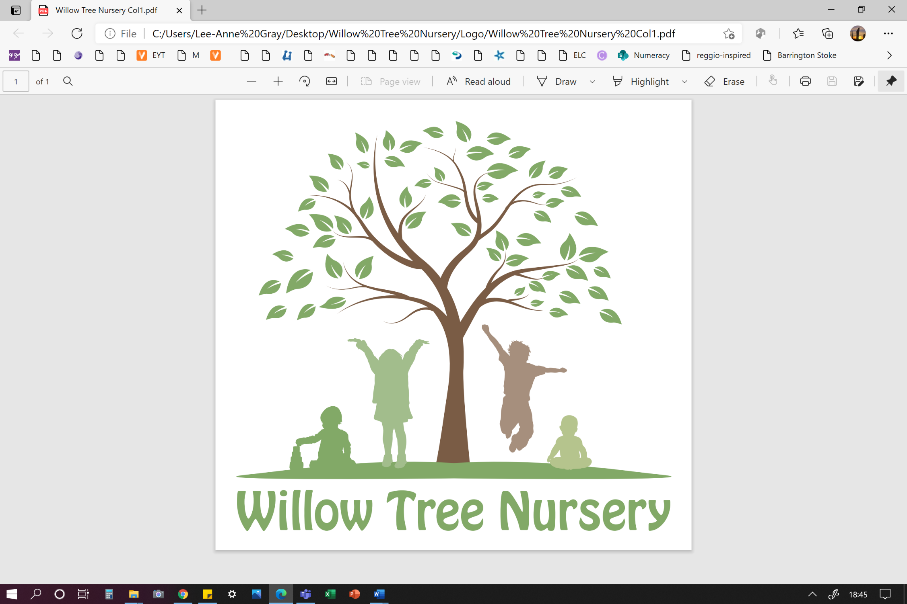 

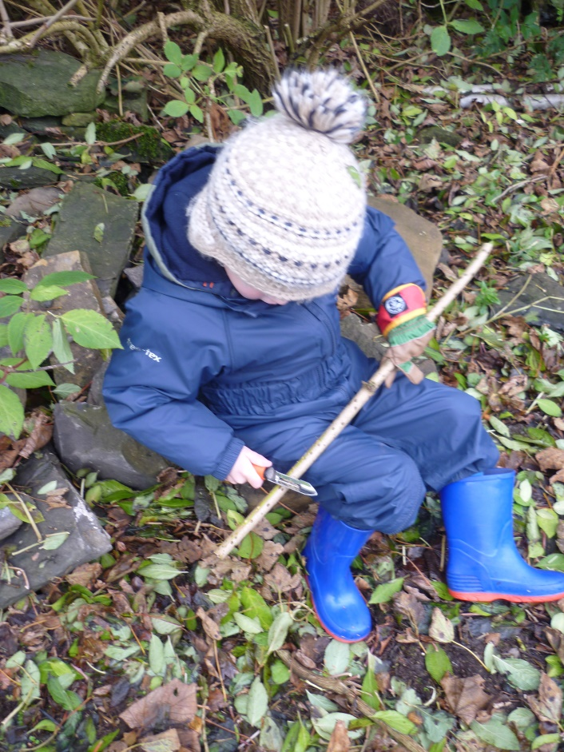**Family Handbook**

**2022-2023**

**Contact details:**

Willow Tree Nursery

Berstane Road

Kirkwall

KW15 1NA

 01856 886686

**🖂** willow.tree@orkney.gov.uk

 willowtreeorkney.co.uk



**Welcome to Willow Tree Nursery**

Hello and a warm welcome to our Willow Tree Nursery Handbook!

Willow Tree Nursery caters for young children aged 6 months – 3 years. Our premises has been refurbished to ensure we comply with all relevant standards for the delivery of Early Learning and Childcare, we have established an experienced team and have a fully resourced setting ready to welcome you and your child.

Our vision for service delivery is to strive to provide a homely environment where children thrive, and families can be assured their children are loved and well cared for. We are now looking forward to trying our very best to realise that in practice. We look forward to working closely with you and your family, chatting with you about what is working well and things that could be done differently.

I hope this handbook is useful but if there is anything else you are wondering or would like more information on, please get in touch.

Cathy Smith

Manager, Willow Tree Nursery

**Our Vision**



*Striving to provide a homely environment where children thrive, and families can be assured that their child is loved and well cared for.*

**Our Values**

At Willow Tree Nursery we value children as unique individuals who are naturally curious and eager to learn from the world around them.  Warm, caring relationships built upon trust and respect are at the heart of our philosophy.  Every family, baby, young child or parent that we have the pleasure of meeting is unique and we will strive to attune to each family’s feelings, needs and wishes to ensure we provide the best possible care.

We believe that all learning is rooted in a child’s early experiences and activity.  By providing stimulating play spaces, developmentally appropriate experiences and sensitive interactions, nurseries like ours can provide support for every individual to flourish.

**Our Aims**

* To create a warm, safe, happy place that meets the needs of the community it serves
* To value parents and carers as their child's most important other and together, celebrate learning and development.
* To build genuine positive relationships with children and their families and connections in our wider community.
* To communicate effectively and be honest and sincere.
* To value play and provide rich, developmentally appropriate experiences in a well-resourced, homely, stimulating environment both indoors and out.
* To listen to children, value them as individuals and celebrate what makes us all unique.
* To continually evaluate what we do and encourage all staff to develop and remain curious so we can strive to provide excellent care and early education at Willow Tree Nursery.

Meet the Team



Our team is made up of both experienced and newly qualified staff, bringing lots of varied experience. The leadership team in the setting includes a full time Manager and two full time Lead Early Years Practitioner (EYP). Cathy will provide overall leadership and strategic direction for the setting with the support of the Lead Practitioners. Lorna M and Lorna L will lead the team, promoting high quality practice. Our Early Years Practitioner team will be your first point of contact as key workers for your child.

‘,’

|  |  |  |  |  |
| --- | --- | --- | --- | --- |
|  |  |  |  |  |
| **Cathy Smith**  Manager | **Lorna MacIntosh**  Lead EYP | **Lorna Lawrance**  Lead EYP | **Natasha Rendall**  EYP | **Hannah Bliss**  EYP |
|  |  |  |  |  |
| **Ruth Scott**  EYP in Training | **Ingrid Nicolson**  EYP (Part Time) | **Jenna Marwick**  EYP (Part Time) | **Sarah Campbell**  EYP (Part time) | **Chloe Beetge**  EYP in Training |
|  |  |  |  |  |
|  |  | **Jessica Spence**  EYSW |  |  |

Our Nursery Rooms

Our play areas are carefully planned and extensively resourced to create inspiring learning environments in which children can grow and learn with confidence. Each playroom has access to the outdoor play area, offering the opportunity for regular outdoor learning opportunities.

Your Baby’s Journey

In our Explorers Room, we have committed staff whose priority is to follow the home routine of each baby as closely as possible. We have a spacious play area with a cosy sleeping area. Your baby will be in a safe environment filled with opportunities to actively explore and discover. There will be sensory stimulation, places to climb, pull up on, every day staff will take babies out for fresh air, enjoying walks round the community or exploring the nursery garden.

We believe quality interactions are key in bonding with your baby and fostering early language development whether through one-to-one conversation, finger rhymes and songs, a game of peek a boo or snuggling up to share the magic of books.

We ask parents to supply their own nappies and milk to ensure continuity between home and nursery for all babies. We will support you with how you feed your baby, if you are continuing to breast feed or bottle feed. We can welcome you to visit during the day to feed your child. We will also follow your routine during the weaning stage and help your baby transition to solid food.

Our staff will listen closely to you to help decide which room is best for your child before any transitions happen. As your peedie person is confident in toddling around, it may be time for them to transition to the Adventurers room.

**The Adult : Child ratio that will be followed with each group of children is as follows:**

|  |  |  |
| --- | --- | --- |
| Age | Explorers (0-2) | Adventurers (2-3) |
| Staff Ratio | 1:3 | 1:5 |



Your Toddler’s Journey

As your baby develops into an inquisitive toddler, they become more involved in doing things for themselves. It is a powerful time full of emotions, struggles and delights and achievements and we are there to help them navigate through this stage of their learning journey. Our Adventurer room is carefully planned to ensure that there are opportunities for lots of repetitive play with familiar routines and experiences for the children to explore outside and in. Our staff are playful and fun and will enjoy learning alongside your toddler.

We play outdoors a lot and experience the weather and seasons. Children learn lots through inquisitively exploring the natural world and we will support and encourage that each day. We will encourage children to manage their own risks through play with sensitive adults close by for support. As a team we use the term ‘freedom with guidance’: giving the children the freedom to explore and discover, rooted in what interests them, but with an adult close by to support, guide and challenge them in their learning and development.

When the time comes to move on, the staff will support you and your child to make the transition to their new three-year-old nursery setting.

The Key Worker Role

We believe relationships are very important when working with young children and their families. We will often be the first people outside of immediate family who you are trusting with the care of your young child so we will focus on building strong, genuine relationships from the outset. Each child and family will be allocated a key worker. The main role of the key worker is to act as a point of contact for families, build a close relationship with the child and monitor their learning and progress. They will update your child’s personal care plan every 3 months to ensure we are meeting their individual needs. You can contact your child’s key worker by phone, seesaw or by emailing [willow.tree@orkney.gov.uk](mailto:willow.tree@orkney.gov.uk).



Session Times and Fees:

The Nursery caters for up to 32 children aged 0-3 years in the building at any one time. Children will be able to attend until they become eligible for funded local authority childcare the term after their third birthday.

At present, the session timetable and charges are as follows:

|  |  |
| --- | --- |
| Morning 0800-1300 (5 hours) | **£30.00** |
| Afternoon 1300-1730 (4.5 hours) | **£27.00** |
| Hot cooked meal at lunch time | **£2.40** |
| Full day 0800-1730 including lunch | **£59.40** |

Closure days

The setting is open year-round, Monday to Friday from 0800-1730. We will close for Orkney Islands Council public holidays, including Dounby Show Day, and on 24th December each year. The setting will be closed to children and staff on these days, and you will not be charged for sessions.

The nursery will also be closed to children on our in-service days throughout the year. These dates will change each year but will be communicated to parents through our Seesaw app. You will not be charged for these days.

Holiday allocation

In addition to the closure days, each child will have a holiday allocation of 4 weeks. If your child attends for 24 hours per week, they will have a holiday allocation of 96 hours per year that could be taken and not charged for. We ask for a minimum of 2 weeks’ notice for all planned holidays where you intend to use your holiday allocation.

Illness and days off beyond holiday allocation

Sick days and non-attendance will be charged at the standard rate. Families are encouraged to discuss any ongoing sickness with the Manager and allowances will be made.

Changing pattern of attendance

Any request to change sessions or increase hours will be subject to the setting’s waiting list. If you would like to reduce hours or cancel your space, we will require 4 weeks’ notice. Any proposed changes to attendance or requests to increase hours should be submitted, in writing, to the manager by emailing [willow.tree@orkney.gov.uk](mailto:willow.tree@orkney.gov.uk)

Ad hoc sessions

Last minute childcare may be available in the form of ad hoc sessions. These sessions are not guaranteed but any available capacity will be offered to any existing families upon request. If you require any ad-hoc sessions, then please email [willow.tree@orkney.gov](mailto:willow.tree@orkney.gov) and Cathy will check availability. These sessions are offered on a first come, first served basis.

Charging

Charging will occur in arrears for the previous month. The charging period will run until the last Friday of every month. At this point your sessions attended, any lunches and additional ad hoc hours will be calculated, and this will be sent to you in an invoice. Charging terms will be in line with the Orkney Islands council policy for service charges. This is available at: [Charging and Concessions Policy (orkney.gov.uk)](https://www.orkney.gov.uk/Files/Finance/2015_2016/Charging_and_Concessions_Policy.pdf)

Your questions answered…

How will staff get to know my child?

Before your child begins their sessions at Willow Tree Nursery you will have the opportunity to visit the setting, meet staff and ask any questions you may have. We will discuss a plan of visits to the setting and how you may want to settle your child. Each child and family are different, and we will tailor our approach to meet your needs. Each child will also have a document entitled ‘My personal plan – all about me’. Staff will work closely with you before your child starts to construct the plan, detailing all information the staff will need to be able to care for your child.

How do drop off and pick up times work?

When you arrive to drop off or collect your child, please ring the bell in the front porch. A member of staff will greet you and there will be the opportunity to pass on any information. We respectfully ask that all children are collected promptly at 1300 or 1730 at the latest, depending on their session time.

Although the session times and charges are set, parents are welcome to drop their child off and pick up to suit your own needs. So, if it is more suitable to drop off at 0830 and collect at 1715, that is no problem. The full day sessions charge will still apply.

What is the best way to contact the setting?

You can contact the setting at any point by telephone or email. The phone number has an answerphone so please leave a message and we’ll get back to you as soon as possible. Our email inbox will be monitored regularly each day 0800-1730.

Joyce, our Clerical Assistant, works part time, 0800-1100 each morning. This is a good time to contact the setting to ensure someone is available to answer your query.



What should my child wear and bring with them?

Children are likely to take part in a variety of activities at nursery, some messier than others, so we recommend that your child does not attend in their best clothes. Comfortable play clothes are best. Children will be encouraged to wear aprons and overalls for messy activities, but we cannot guarantee that they will always be effective.

Each child should come to nursery with a bag containing:

* At least one full change of clothes. If your child is staying with us all day, it may be advisable to have several changes.
* Any changing supplies they require including all nappies. Staff will use the supplies as directed by families on the child’s personal plan.
* Lunch – if the child is not having the nursery lunch.
* Any blankets or comforters they may require for sleeping.

Children should also bring appropriate clothing for the weather. This would include:

* A pair of welly boots. You can leave a pair at nursery if you wish.
* A waterproof coat or waterproof suit to enable play outdoors in all weathers.
* For sunny weather, we ask that all children are dressed appropriately for the sun and, if possible, arrive with sunscreen already applied. We would suggest light long-sleeved tops and sunhats that shade face and cover the neck. Please provide sunscreen suitable for your child in their bag which can be reapplied by staff throughout the day.

 *Babies will not spend long periods of time outdoors in direct sunlight and we will be careful to discuss your preferences for having children outdoors in the warmest*

*weather.*



What happens if my child becomes unwell?

If your child becomes unwell at nursery, we will contact you straight away. It is important that we have up to date emergency contact numbers for parents and others who we can get in touch with if this is the case.

There are some childhood illnesses that require a child to be excluded from the setting for a period. These can be seen at: [exclusion-criteria-for-childcare-and-childminding-settings-poster-2018.pdf (nhsggc.org.uk)](https://www.nhsggc.org.uk/media/254151/exclusion-criteria-for-childcare-and-childminding-settings-poster-2018.pdf)

What is a ‘personal plan’?

Each child will have a document that details information about them and how to meet their needs. Parents and practitioners will all feed into the document and agree the content. This will then be kept under review and updated to reflect your changes as your child grows and develops and their needs and preferences change. You can ask to make changes to this at any point, it will be a working document. You will construct the initial document with your key workers before your child starts with us.

Typically, it will contain information about:

* Information about your child’s likes, dislikes and preferences
* Information about family and who will be collecting your child from nursery
* Anything that makes your child upset or worried and what soothes them when upset
* Favourite stories, songs rhymes etc.
* Food and weaning preferences. Milk feeding preferences. Allergies and intolerances.
* Changing routines and preferences
* Sleep routines and preferences
* Any medical conditions or additional needs that staff should be aware of or areas that may need specialist support or care.
* A section for any other information that you feel you would like to share with the staff who will be caring for your child.

Meals and snacks

All our meals and snacks will be prepared in line with the Scottish Government guidance for nursery snacks, meals and drinks. This document is called ‘Setting the Table’ and it can be accessed at: [Setting the table (healthscotland.com)](http://www.healthscotland.com/uploads/documents/30341-Setting%20the%20Table.pdf)

Snacks

Children will have the opportunity for a healthy snack during the morning and afternoon sessions. These snacks will mostly consist of a combination of fruits, vegetables and some carbohydrates such as bread or crackers. We will provide snack menus each week so that parents are aware of the snacks being offered. You will have the opportunity to let us know in your child’s personal plan whether they have any allergies or intolerances. This information will be shared with everyone involved in preparing and serving snacks and drinks. We will offer cow’s milk and water to drink. If your child does have an allergy or intolerance, we will do our best, in consultation with families, to provide a suitable dietary alternative. Parents are also welcome to provide their own snacks if they would prefer. There is no additional charge for nursery snacks.

Lunch

Hot nursery lunches are provided by Papdale School Kitchen and will be prepared there and delivered each day. Menus will be provided in advance and lunches can be ordered on the day when you drop your child off. There is a separate charge for nursery lunch of £2.40 per day. This will be recorded and added to the next month’s bill.

Parents can also choose to send a packed lunch with their child. All lunch items should be sent in a container, labelled with your child’s name. This will then be refrigerated until lunch time. We ask that parents follow the guidance on healthy choices for lunches and do not send chocolate and sweets.

First Aid and Medication

First Aid

We will always have qualified paediatric first aiders on the premises. Staff will support children who require basic first aid. You will always be given information about what has happened to your child if they require any first aid at nursery. If your child has a bump to the head at nursery, we will monitor them throughout the day, but we will also contact you by phone to ensure the message is passed on.

Medication

From time to time your child may require medication to be administered at the setting. We have medication policy which is in line with the Care Inspectorate Guidance ‘Management of medication in day-care of children and childminding services. This can be accessed at [Childrens service medication guidance.pdf (careinspectorate.com)](https://www.careinspectorate.com/images/documents/1427/Childrens%20service%20medication%20guidance.pdf). We will need you to fill in a form with details about the medication and how and when it should be administered.

Families as partners

We are committed to ensure families can be as involved in the life and the work of our settings as they can be, but we also recognise that many parents work, and finding time to engage with the nursery can be tricky. We will keep you up to date with nursery information by email as well as our communication app, ‘Seesaw’. We will use our newsletter to share information about what has been happening in the setting.

As we are committed to constant improvement, we will regularly seek your feedback in a variety of ways as we self-evaluate and aim to make improvements that will positively impact on the children.

Your child’s learning and development

# Young children are constantly learning from the world around them through the environment they are in, the interactions with others and the experiences that are offered to them. We promote the fact that parents and carers are a child’s first and most important educators and we will discuss your child’s learning and development with you regularly and together celebrate their learning and progress.

# The learning environment at Willow Tree Nursery

The space at Willow Tree, both indoors and out, will be set up to provide a stimulating learning space for young children. We will have spaces to be busy and messy, spaces to be quiet and rest and lots of resources that spark a child’s creativity and curiosity.

# Interactions with children

# Our staff are skilled at interacting with young children. They continuously work to support your child’s language development through songs, stories, rhymes and everyday

# interactions. Staff support children to interact with others and learn social skills as they play.

# Experiences offered

# Staff plan learning experiences in a variety of ways. Experiences are supported and extended by staff through play each day/week. These experiences may be shared with families via photographs on Seesaw. If you have any ideas as to how we may be able to extend the children’s learning or have any skills which you may be able to share, we’d be delighted to hear from you.

**Learning Journey Books**

Each child has a Learning Journey Book which is a bit like a scrap book, where children and nursery staff gather information about each child’s individual learning. The books contain photos, observations and pieces of work that the children produce. These books are sent home from time to time, but they are accessible all year round for children and parents to access in the setting.

Continuous improvement

Willow Tree Nursery follows quality assurance procedures using ‘How Good is our Early Learning and Childcare?’ (Education Scotland 2014) and ‘A quality framework for day-care of children, childminding and school aged childcare’ (Care Inspectorate 2021). These documents help us to ensure we keep the service that we provide under constant review, taking the views of children, parents and staff into account. We look inwards at our own service, outwards for best practice examples and forward to ensure we are on a journey of continuous improvement. If you have any suggestions of areas in which we could improve, please let us know.

Comments, compliments and complaints

Willow Tree Nursery is committed to delivering a quality service to all our families. We very much welcome comments about the service we provide to help us evaluate our practice. Please share your thoughts, on any aspect of the provision, with a member of our team. We will also regularly ask for feedback in a variety of ways throughout the year.

We aim to ensure the highest standards of care are upheld. Therefore, we encourage you to get in touch as soon as possible if this is not the case. Please share any concern with the **Manager, Cathy Smith** who will make sure your concern is acted upon. We will talk to you about how we plan to move forward and check that you feel the matter is resolved. This is in line with The Orkney Islands Council complaints procedures, displayed on the information board. Alternatively, please contact **Catherine Diamond**, Early Years’ Service Manager, Orkney Islands Council on **01856 873535** **ext: 3220**.

We are also a service that is registered with and regulated by the Care Inspectorate and you can also contact them if you are not happy about any aspect of the service. They can be contacted on 0345 600 9527. More information about the Care Inspectorate and the National Care Standards can be found at [www.careinspectorate.com](http://www.careinspectorate.com) .